
Object Marker
User's Guide

Published: 23 June 2018

Table of Contents
1 Introduction 3
2 Using Object Marker 4
2.1 Startup Window 4
2.2 How to Mark Objects with Object Marker 4
2.2.1 Setting Up Marking Parameters 4
2.2.2 The Marking Process 7

- Introduction
The purpose of this user’s guide is to instruct the end user on how to work with the Object Marker tool for Microsoft Dynamics NAV. The target audience includes testers, developers, and program managers working on upgrade projects.
Upon the end of the work on an upgrade project, the customer may request the modified/added objects in the .txt/.fob format. In order to export the required objects to a .txt/.fob file, it is necessary to select them in the Object Designer first. As we deal with a big number of objects, it is very time-taking to do it manually. Moreover, it is very easy to make a mistake during the selection process.
The Object Marker tool was created to automate and simplify the process of exporting the necessary objects from Microsoft Dynamics NAV to a .txt/.fob file. According to the parameters specified by the user, the tool marks the necessary objects in the Object Designer of Microsoft Dynamics NAV according to a list of objects specified in a separate file. The tool verifies the objects in the Object Designer whether they are present in the object list file. If an object is present in the file, the tool marks it in the Object Designer. Then, either the user manually exports the marked objects selecting them with the help of the Marked Only function or lets the tool do this automatically.
The tool also provides the user with additional features, such as adding custom text to the version lists and changing the Modified field value for the marked objects.
- Using Object Marker
This section describes how to mark, select, and export (if necessary) the required objects using the Object Marker tool.
  - Startup Window
When you start the Object Marker by running ObjMark.exe for the first time, the following startup window appears:
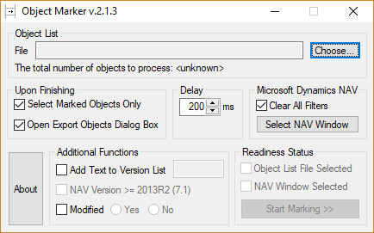
Figure 1: The default view of the Object Marker startup window
Note
During your subsequent starts of the Object Marker, the tool will display the startup window with the parameters you set up the previous time. These settings are stored in the objmark.ini file, located in the same folder with the tool.
  - How to Mark Objects with Object Marker
    - Setting Up Marking Parameters
To mark the necessary object using the Object Marker, you must set up the marking parameters in the startup window. To set up the parameters, fill in the following fields in the Object Marker window:
- In the Object List pane, select the file with the list of objects to be marked. Click Choose next to the File field. The object list in the selected file must be organized according to the following rules:
- Each line contains only one object.
- The formula of writing a line is as follows: <object_type><object_number>.
- Object types are case-insensitive and must be either a three-character abbreviation or a full object type name.
- The tool does not process spaces, file extensions, and blank lines. If any of these are present, the tool skips them.
- Each line must start with a three-character abbreviation of an object type or its full type name. If the line starts with any other set of characters, the program skips the line even the line is necessary for marking.
See an example of the file with the list of objects below:
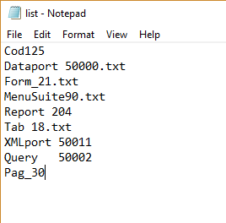
Figure 2: An example of the file with the list of objects representing variants of object type and object ID specification
After the file is selected, the tool processes it and displays the total number of objects to process in the Object List pane and sets the Object List File Selected check box to the selected state as shown below:
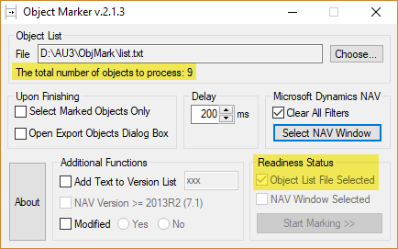
Figure 3: The object list file selected
Also a message appears in the notification area, containing the information about the elapsed time and the total number of objects to be processed:
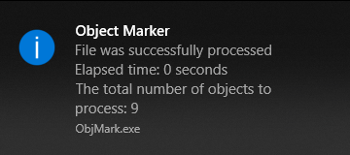
Figure 4: The notification area message
- In the Delay pane, set up how much time will be necessary for the CPU to process each step of the marking. A step in a marking process is an emulation of pressing a key on the keyboard. Thus, you should select the optimal time depending on the load of the CPU. If you set up too little time for processing, the CPU may not have enough time for processing objects, which will result in the marking errors. And if you set up too much delay time, the process of marking may take a significant amount of time, but it is safer. The recommended delay time is 200-300 ms.
- In the Upon Finishing pane, fill in the following check boxes:
- Select Marked Objects Only – Select this check box, if you want the tool to filter the objects by marked only and select them upon finishing the marking process.
- Open Export Objects Dialog Box - Select this check box, if you want the tool to open the Export Objects window in order for you to export the marked and selected objects upon finishing the marking process.
Note
The Open Export Objects Dialog Box check box can be selected only in combination with the Select Marked Objects Only check box.
- In the Additional Functions pane, fill in the following check boxes:
- Add Text to Version List – Select this check box if you need to add text to the version list of all marked objects. You can type the text to be added in the text box next to the check box, which becomes enabled only after you select the Add Text to Version List check box.
Note
The maximum number of characters in a version list for Microsoft Dynamics NAV must not exceed 80. If the added text in addition to the original version list exceeds the limit, the tool will interrupt the marking process for such object during the marking process and the following dialogue box will be displayed:
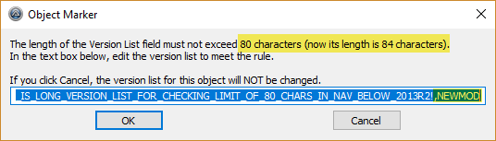
Figure 5: Modifying the version list during the marking process
- Modified – Select this check box if you need to select the Modified field for all marked objects. Set the radio button to ‘Yes’ to have the tool select the Modified field for all marked objects. Set the radio button to ‘No’ to have the tool clear the Modified field for all marked objects. If you leave the Modified check box cleared, the tool will not change the Modified field in the Object Designer.
- In the Microsoft Dynamics NAV pane, select the Clear All Filters check box to have the tool clear all filters in the Object Designer before starting the marking process.
- In the Microsoft Dynamics NAV pane, click Select NAV Window. The tool hides its window and a message appears in the notification area indicating that now you must activate the Microsoft Dynamics NAV window where the marking process will be performed.
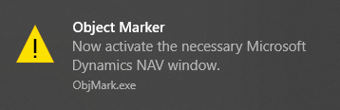
Figure 6: Activating the Microsoft Dynamics NAV window message
After you have activated the necessary Microsoft Dynamics NAV window, the Object Marker window is displayed again. The Microsoft Dynamics NAV window title changes to Object Marker is working with this window. Do not touch the mouse or keyboard during the marking process. Also a message appears in the notification area indicating that Microsoft Dynamics NAV window title has been changed and will be restored after the marking process is completed.
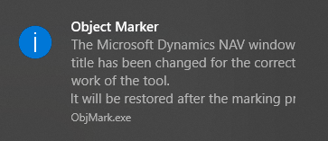
Figure 7: Modifying the Microsoft Dynamics NAV window title message
Figure 8: Modified Microsoft Dynamics NAV window title
Note
Since Object Marker tool uses emulation of keystrokes, the Object Designer must have correct order of columns and interface language to be able to filter proper object types and object IDs, change Modified field value, update Version List field.
Currently, working language is English; order of columns to appear in Object Designer: Type, ID, Name, Modified, Version List.
Presence and order of other columns do not matter.
Figure 9: Correct order of columns in Object Designer

    - The Marking Process
Now the tool is ready to start the process of marking objects. At this stage, if all the required marking parameters have been set up, the Readiness Status pane must look as follows:
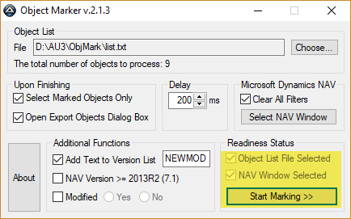
Figure 10: Readiness Status
If either the object list file has not been selected or the necessary Microsoft Dynamics NAV window not activated or both, this information will be displayed in the Readiness Status pane indicating the following:
- Object List File – If this check box is not selected, it indicates that a file with a list of object to process as one of the minimum object marking requirements has not been selected yet. On how to specify the object list file, see the first step in the Setting Up Marking Parameters section.
- NAV Window Selected - If this check box is not selected, it indicates that the necessary Microsoft Dynamics NAV window where the marking process is to be performed, has not been made active yet. On how to activate the necessary Microsoft Dynamics NAV window, see step 6 in the Setting Up Marking Parameters section.
- Start Marking –If this button is not active, it indicates that the previous two necessary conditions described above are not met yet.
Note
The Object List File Selected and NAV Window Selected check boxes in the Readiness Status pane are for information purpose only and cannot be edited manually. These check boxes indicate whether all the necessary parameters have been set up for the tool to be able to start the marking process.
To start the marking process, click Start Marking.
The following window appears:
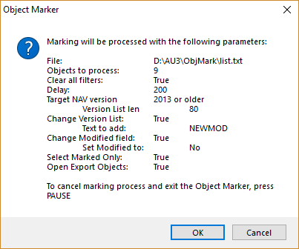
Figure 11: Confirming the selected marking parameters
In this window, verify whether you have correctly specified the marking parameters. If you approve the marking options, click OK. Click Cancel, to cancel the marking process and return to the parameters setup stage. When the marking process starts, the Object Marker window is hidden.
Note
For the correct work of the Object Marker, do not touch the mouse or keyboard during the marking process because the tool uses the emulation of pressing the keys on the keyboard and the Microsoft Dynamics NAV must be active.
You can cancel the marking process at any time by pressing PAUSE.
After the marking process is completed, the following message appears in the notification area:
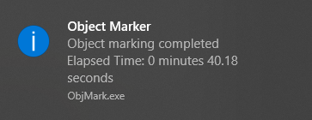
Figure 12: The object marking process completed message
Upon the successful finish of the object marking steps (these may or may not include the stage of exporting objects to a .txt/.fob file according to the parameters set up in the Setting Up Marking Parameters section), the Object Marker window is displayed again.

